- What are HTML attributes?

HTML attributes are attributes that help describe specific details about a HTML tag or element. They also help provide additional information about HTML elements.

- Give five examples of HTML attributes?

- width=”x px”
- height=”x px”
- font-size=”x px”
- title=”x”
- href=”x.jpg”

- What do we suggest for HTML attributes?

We suggest using lowercase for HTML attributes, even though capitals are allowed in HTML. This is because stricter programming languages demand lowercase such as XHTML and Turing 4.1.1.

- Should Single or Double Quotes be used?

Usually, double quotes should be used. However, if the content inside contains double quotes, then single quotes should be used and vice versa.

- Check the website:
http://www.w3schools.com/tags/default.asp
List the HTML tags not supported in HTML 5.

<acronym>
<applelet>
<basefont>
<big>
<center>
<dir>
<font>
<frame>
<frameset>
<noframes>
<strike>
<tt>

- How many different headings are there? What are they?

There are 6 headings. They are: <h1>, <h2>, <h3>, <h4>, <h5>, <h6>. <h1> is the largest heading and <h6> is the smallest heading.

- Why do we use HTML Horizontal Rules?

Horizontal rules make a horizontal line across a HTML document. They can be used to separate content.

- What is the HTML <head> Element?

The HTML <head> element is used to contain meta data that helps the browser and search engines understand the web page. Meta data is not displayed on the web page.

- What is the HTML <title> element?

The <title> element is used to give a title to the whole document. The title is displayed in a web browser as the tab name.

- Give a few examples of Meta Elements.

<meta>
<title>
<link>

- How to view the source code of a web page?

To view the source code of a web page, right click an element in Google Chrome or Firefox on the webpage and click view source.

- Create a page (html_wk2_q12.html) that looks like the following using the block quote tag, the horizontal rule tag, center tag and the predefined text tag.

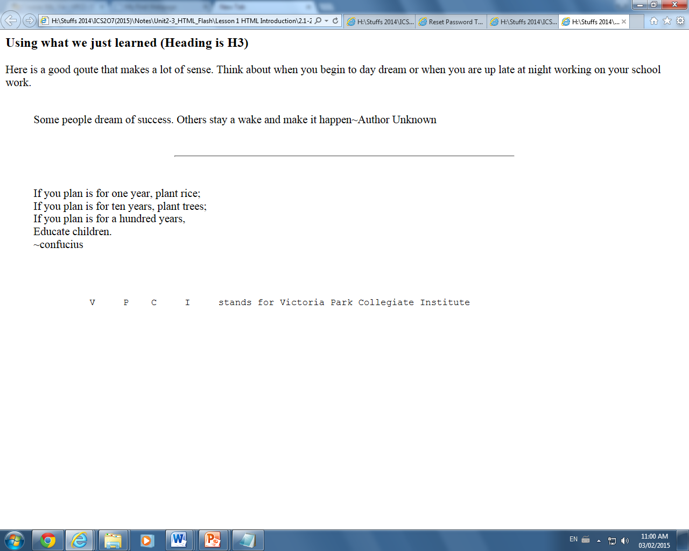

- Create a page (html_ wk2_q13.html) that looks like the following using the Heading 1 tag, break paragraph tags and aligning attributes within the paragraph tags.

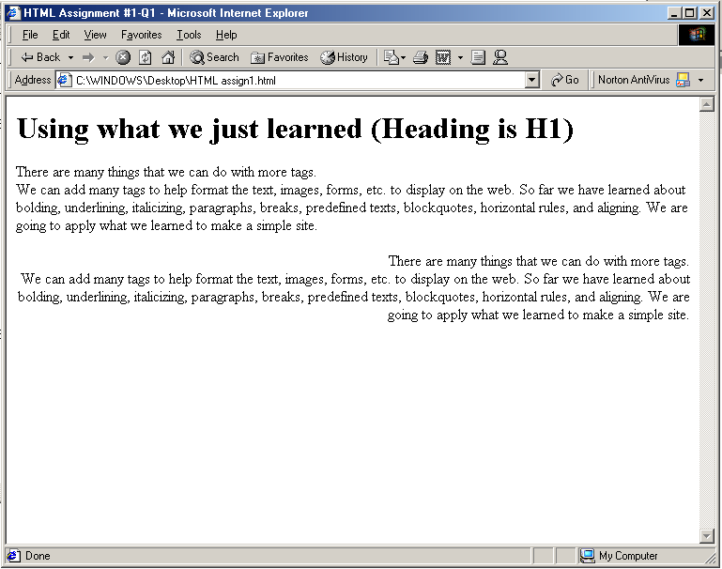

- Create a page (html_ wk2_q14.html) that looks like the following using the font tags, size tags and color tags.

